CSCD350 ASSIGNMENT 6

Team: Fast Fire File Flyers(4F) Lead: Brandon Fowler

Members: Zach Lontz, Brandon Fowler, Daniil Borisov, James White

Create a new team project with team lead's account, and add team members to the project:

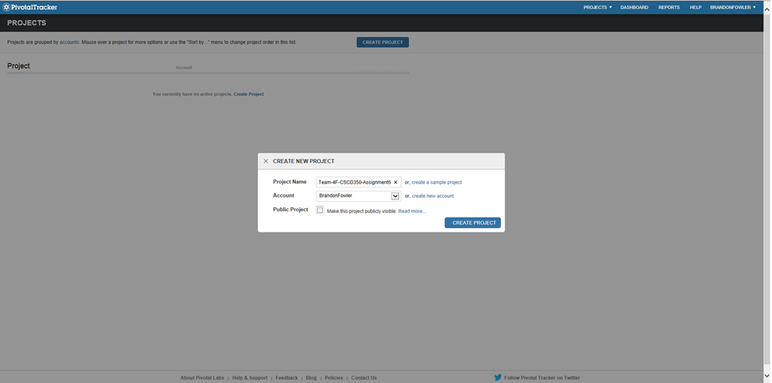

Create a test story for Zach, then add it to the back log:

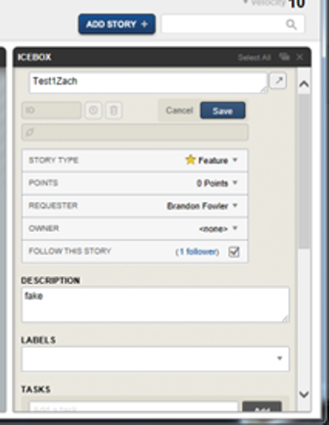

Zach finishes and delivers his test story, and it is accepted:

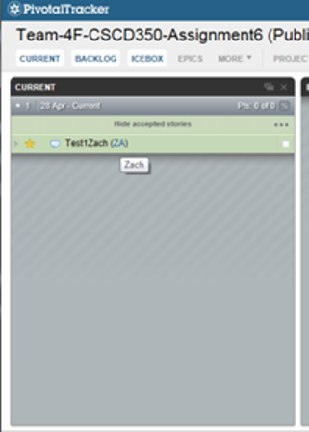

Create a test story for Daniil, then add it to the back log:

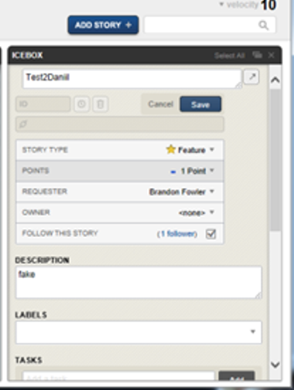

Daniil finishes and delivers his test story, and it is accepted:

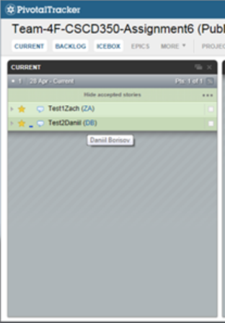

Create a test story for James, then add it to the back log:

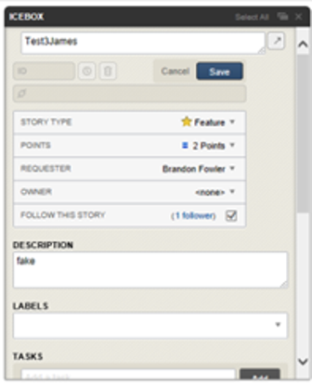

Create a test story for Brandon, then add it to the back log:

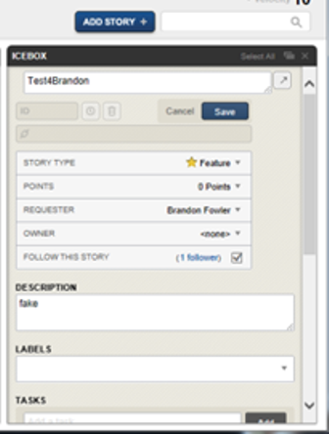

Brandon finishes and delivers his test story, and it is accepted:

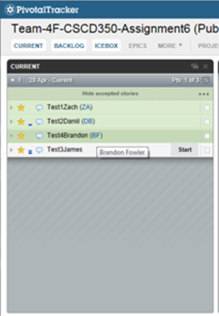

James finishes and delivers his test story, and it is accepted:

